From: Ron Holmes MSM
 | Artillery Clerks’ Association  Germany Reunion Secretary  2IC The Holmes Residence  Max-Planck Str 75, 33659 Bielefeld, Germany  Email: crossedquills@gmail.com |  | 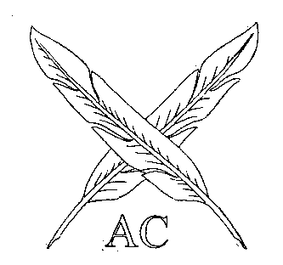
Association Members  On FB or known Email |  | Reference: AC-G-2018  Date: 10 July 2018

ARTILLERY CLERKS’ REUNION AND ASSOCIATION DINNER GERMANY
20 OCTOBER 2018

The Artillery Clerks’ Reunion and Association Dinner will be held in Catterick Barracks, Bielefeld, hosted by WO1 (RSM BFG) Simon Nicholson RA on the 20th October 2018. Partners are invited. Guest of honour is Comd BFG Brig R M Clements (former CO 39 Regt RA).

Friday 19 October

Self transport to Catterick Bks, Book into the mess via the Guardroom
1900 hrs Meet in the Sgts’ Mess bar and then possible taxi down town Bielefeld.

Saturday 20 October

0900-1100 hrs - Brunch PAYD
1845 hrs - Arrive in the Sgts` Mess
1900 hrs - Guests arrive, group photograph
1930 hrs - Reunion Dinner, dress Black tie/mess dress

Sunday 21 October

1000 hrs - Brunch and departure

The Reunion Secretary will collect a cash approximately 40 Euro per person (TBC) for the dinner and accommodation on your arrival.

Accommodation: There are two family rooms and the remainder is singly transit.

Please forward completed attendance form, to reach me by 1 September 2018 (email with all details will suffice). There will be no acknowledgement, but feel free to e-mail me. The Association web and FB page will be updated regularly with a list of those who have confirmed their attendance. Please be sure to visit this site on a regular basis to keep current with developments.

If you are unable to attend, it would be appreciated if you could send some form of message or greeting to be included in the dinner programme.

The Main Gate Guard room Catterick Bks will have a list of attendees and all access should be through this gate. Sat Nav Address: Detmolder Str. 460, 33605 Bielefeld.

This letter is being sent (email, FB only). If there are former Artillery Clerks that you know out there, who would like to attend the Reunion, get them to contact me.

Ubique

Ron Holmes
Germany Reunion Secretary

Attached:

Return form

Email To: Ron Holmes
Max-Planck Str 75
33659 Bielefeld
Germany
Crossedquills@gmail.com
015156649076

AC GERMANY DINNER 19-21 OCT 2018

ATTENDANCE PROFORMA
From:

Mob No:

E-Mail Address:

Transport arrangements or Vehicle details: Registration, Make, Model, Colour

I cannot make the dinner, see my message:
xxx

Oh yes, I will be attending the reunion

Accommodation Required Yes/No

Arriving on Friday/Saturday at hrs (approximate)

Special dietary needs (Reunion Dinner only)

PLEASE EMAIL TO THE GERMANY SECRETARY BY
1 SEPTEMBER 2018

